Задача 18. Найти производную указанного порядка.
18.1. 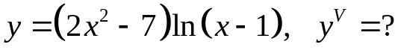
y'= 4xln(x-1)+(2x²-7)/(x-1)
y''= 4ln(x-1)+ 4x/(x-1) + 4x(x-1)-2x²+7 = 4ln(x-1) + 6x²-8x+7
(x-1)² (x-1)²
y'''= 4/(x-1) + (12x-8)(x-1)²-2(x-1)( 6x²-8x+7) = 4x²-12x-2
(x-1)⁴ (x-1)³
y''''= (8x-12)(x-1)³-3(x-1)²(4x²-12x-2) = -4x²+16x+18
(x-1)⁶ (x-1)⁴
y'''''= (-8x+16)(x-1)⁴-4(x-1)³(-4x²+16x+18) = 8x²-40x-88
(x-1)⁸ (x-1)⁵
18.2. 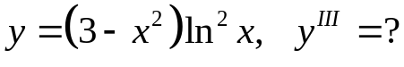
y'= -2xln²x + 2lnx(3-x²)
x
y''= -2ln²x-4xlnx+-4x²lnx+2(3-x²)-2(3-x²)lnx =
x x²
= -2ln²x–4lnx - 2x²lnx+6lnx+2x²-6
x²
y'''= -4lnx – 4/x – (4xlnx+2x+6/x+4x)x²-2x(2x²lnx+6lnx+2x²-6) =
x x⁴
= 12lnx-4x²lnx-6x²-18
x³
18.3. 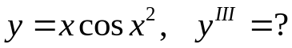
y'= cosx²-2x²sinx²
y''= -2xsinx²-4xsinx²-4x³cosx² = -6xsinx² – 4x³cosx²
y'''= -6sinx²-12x²cosx²-12x²cosx²+8x⁴sinx² = 8x⁴sinx²-6sinx²-24x²cosx²
18.4. 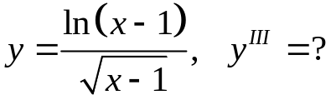
y'= √(x-1)/(x-1) – ln(x-1)/2√(x-1) = 2-ln(x-1)
x-1 2(x-1)^{3/2}
y''= -2√(x-1)-3√(x-1)(2-ln(x-1)) = 3√(x-1)ln(x-1)-8√(x-1)
4(x-1)³ 4(x-1)³
y'''=((3ln(x-1))/(2√(x-1))+3√(x-1)/(x-1)-8/2√(x-1))(x-1)³-3(x-1)²(3√(x-1)ln(x-1)-8√(x-1)) =
4(x-1)⁶
= 46√(x-1)-15√(x-1)ln(x-1)
8(x-1)⁴
18.5. 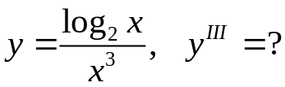
y'= x²/lnx-3x²log₂x = 1-3ln2log₂x
x⁶ ln2 x⁴ ln2
y''= -3x³-4x³(1-3ln2log₂x) = 12ln2log₂x-7
x⁸ ln2 x⁵ ln2
y'''= 12x⁴+5x⁴(12ln2log₂x-7) = 60ln2log₂x-23
x¹⁰ ln2 x⁶ ln2
18.6. 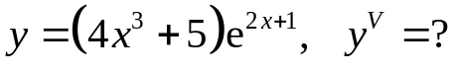
y'= 12x²e^{2x+1}+2(4x³+5)e^{2x+1}= (8x³+12x²+10)e^{2x+1}
y''= (24x²+24x) e^{2x+1}+2(8x³+12x²+10)e^{2x+1}=(16x³+48x²+24x+20) e^{2x+1}
y'''= (48x²+96x+24)e^{2x+1}+2(16x³+48x²+24x+20)e^{2x+1}= 16(2x³+9x²+9x+4)e^{2x+1}
y''''= 16((6x²+18x+9)e^{2x+1}+2(2x³+9x²+9x+4)e^{2x+1})= 16(6x³+24x²+36x+17)e^{2x+1}
y'''''= 16((18x²+48x+36)e^{2x+1}+2(6x³+24x²+36x+17)e^{2x+1})= 16(12x³+72x²+120x+70)e^{2x+1}
18.7. 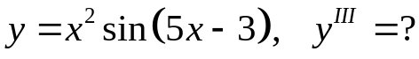
y'= 2xsin(5x-3)+5x²cos(5x-3)
y''= 2sin(5x-3)+10xcos(5x-3)+10xcos(5x-3)-25x²sin(5x-3) = 2sin(5x-3)+20xcos(5x-3)-
-25x²sin(5x-3)
y'''= 10cos(5x-3)+20cos(5x-3)-100xsin(5x-3)-50xsin(5x-3)-125x²sin(5x-3)= 30cos(5x-3)-
-150xsin(5x-3)-125x²sin(5x-3)
18.8. 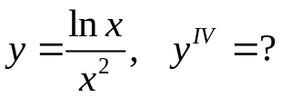
y'= x-2xlnx = 1-2lnx
x⁴ x³
y''= -2x²-3x²(1-2lnx) = -5+6lnx
x⁶ x⁴
y'''= 6x³-4x³(6lnx-5) = 26-24lnx
x⁸ x⁵
y''''= -24x⁴-5x⁴(26-24lnx) = 120lnx-154
x¹⁰ x⁶
18.9. 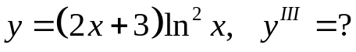
y'= 2ln²x+2lnx(2x+3)
x
y''= 4lnx/x+ 2(2x+3)+4xlnx-4xlnx-6lnx = 4xlnx+4x+6-6lnx
x² x²
y'''= (4lnx+8-6/x)x²-2x(4xlnx+4x+6-6lnx) = 12lnx-4xlnx-18
x⁴ x³
18.10. 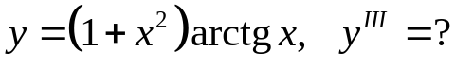
y'= 2xarctgx+1
y''= 2arctgx+2x/(1+x²)
y'''= 2/(1+x²)+ 2(1+x²)-4x² = 4/(1+x²)²
(1+x²)²
18.11. 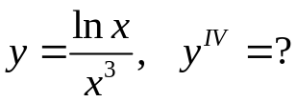
y'= x²-3x²lnx = 1-3lnx
x⁶ x⁴

y''= -3x³-4x³(1-3lnx) = -7+12lnx
x⁸ x⁵
y'''= 12x⁴-5x⁴(12lnx-7) = -23-60lnx
x¹⁰ x⁶
y''''= -60x⁵+6x⁵(60lnx+23) = 360lnx+78
x¹² x⁷
18.12. 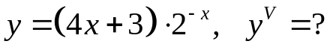
y'= 4*2^{-x}-(4x+3)2^{-x}lnx
y''= -4ln2*2^{-x}-4ln2*2^{-x}+(4x+1)ln²2*2^{-x}= 2^{-x}ln2(4xln2+ln2-8)
y'''= -2^{-x}ln²2(4xln2+ln2-8)+4*2^{-x}ln²2= 2^{-x}ln²2(12-4xln2-ln2)
y''''= -2^{-x}ln³2(12-4xln2-ln2)-4*2^{-x}ln³2= 2^{-x}ln³2(4xln2+ln2-16)
y'''= -2^{-x}ln⁴2(4xln2+ln2-16)+4*2^{-x}ln⁴2= 2^{-x}ln⁴2(ln2-4xln2-12)
18.13. 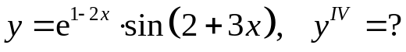
y'= -2e^{1-2x}sin(2+3x)+3e^{1-2x}cos(2+3x)= e^{1-2x}(3cos(2+3x)-2sin(2+3x))
y''= -2e^{1-2x}(3cos(2+3x)-2sin(2+3x))+e^{1-2x}(-9sin(2+3x)-6cos(2+3x))= e^{1-2x}(-12cos(2+3x)-5sin(2+3x))
y'''= -2e^{1-2x}(-12cos(2+3x)-5sin(2+3x))-e^{1-2x}(-36sin(2+3x)+15cos(2+3x))= e^{1-2x}(46cos(2+3x)+9sin(2+3x))
y''''= -2e^{1-2x}(46cos(2+3x)+9sin(2+3x))+e^{1-2x}(-27sin(2+3x)+138cos(2+3x))= e^{1-2x}(120cos(2+3x)-119sin(2+3x))
18.14. 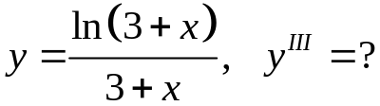
y'= 1-ln(3+x)
(3+x)²
y''= -(3+x)-2(3+x)(1-ln(3+x)) = -3+2ln(3+x)
(3+x)⁴ (3+x)³
y'''= 2(3+x)²-3(3+x)²(2ln(3+x)-3) = 11-6ln(3+x)
(3+x)⁶ (3+x)⁴
18.15. 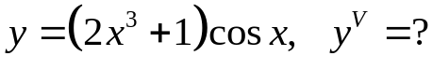
y'= 6x2cosx-2x³sinx-sinx
y''= 12xcosx-12x²sinx-2x³cosx-cosx
y'''= 12cosx-36xsinx-18x²cosx+2x³sinx+sinx
y''''= 2x³cosx+18x²sinx+6xsinx+cosx-48sinx-72xcosx
y'''''= 24x²cosx-2x³sinx+108xsinx+6xcosx+5sinx-120cosx
18.16. 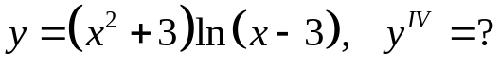
y'= 2xln(x-3)+x²+3
x-3
y''= 2ln(x-3) + 2x/(x-3) + 2x²-6x-x²-3 = 2ln(x-3) + 3x²-12x-3
(x-3)² (x-3)²
y'''= 2/(x-3) + (6x-12)(x-3)-2(x-3)( 3x²-12x-3) = -4x²+18x+12
(x-3)⁴ (x-3)³
y''''= (-8x+18)(x-3)³-2(x-3)²(-4x²+18x+12) = 6x-78
(x-3)⁶ (x-3)⁴
18.17. 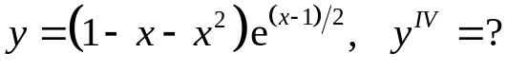
y'= 1/2*e^{(x-1)/2}(1-x-x²)+ e^{(x-1)/2}(-1-2x)= 1/2* e^{(x-1)/2}(-1-5x-x²)
y''= 1/4*e^{(x-1)/2}(-1-5x-x²)+ 1/2*e^{(x-1)/2}(-5-2x)= 1/4* e^{(x-1)/2}(-11-9x-x²)
y'''= 1/8*e^{(x-1)/2}(-11-9x-x²)+ 1/4*e^{(x-1)/2}(-9-2x)= 1/8* e^{(x-1)/2}(-29-13x-x²)
y''''= 1/16*e^{(x-1)/2}(-29-13x-x²)+ 1/8*e^{(x-1)/2}(-13-2x)= 1/16* e^{(x-1)/2}(-55-17x-x²)
18.18. 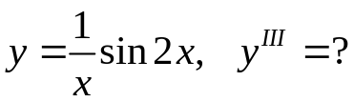
y'= 2xcos2x+sin2x
x²
y''= (2cos2x-4xsin2x+cos2x)x²-2x(2xcos2x+sin2x) = -xcos2x-4x²sin2x-2sin2x
x⁴ x³
y'''= (-cos2x+2xsin2x-8xsin2x-8x²cos2x-4cos2x)x³-3x²(-xcos2x-4x²sin2x-2sin2x) =
x⁶
= 6x²sin2x-8x²cos2x-2xcos2x+6sin2x
x⁴
18.19. 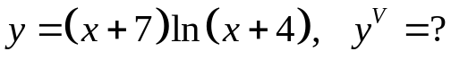
y'= ln(x+4) +(x+7)/(x+4)
y''= x+4+x+4-x-7 = x+1
(x+4)² (x+4)²
y'''= (x+4)²-2(x+1)(x+4) = 2-x
(x+4)⁴ (x+4)³
y''''= -(x+4)³-3(x+4)²(2-x) = 2x-10
(x+4)⁶ (x+4)⁴
y'''''= 2(x+4)⁴-4(x+4)³(2x-10) = 48-6x
(x+4)⁸ (x+4)⁵
18.20. 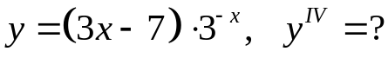
y'= 3*3^{-x}-(3x-7)3^{-x}ln3= 3^{-x}(3-3xln3+7ln3)
y''= -3^{-x}ln3(3-3xln3+7ln3)+3*3^{-x}ln3= 3^{-x} ln²3(7-3x)
y'''= -3^{-x}ln³3(7-3x)-3*3^{-x}ln²3= 3^{-x} ln²3(3xln3-7ln3-3)
y'''= -3^{-x}ln³3(3xln3-7ln3-3)+3*3^{-x}ln³3= 3^{-x} ln³3(3xln3-7ln3+6)
18.21. 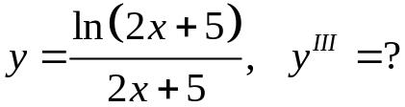
y'= 1-2ln(2x+5)
(2x+5)²
y''= -2(2x+5)-2(2x+5)( 1-2ln(2x+5)) = -4+4ln(2x+5)
(2x+5)⁴ (2x+5)³
y'''= 4(2x+5)²-3(2x+5)²(4ln(2x+5)-4) = -8-12ln(2x+5)
(2x+5)⁶ (2x+5)⁴
18.22. 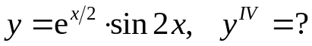
y'= 1/2*e^{x/2}sin2x+2e^{x/2}cos2x= e^{x/2}/2*(sin2x+4cos2x)
y''= e^{x/2}/4*(sin2x+4cos2x)+ e^{x/2}/2(2cos2x-8sin2x)= e^{x/2}/4*(-15sin2x+8cos2x)
y'''= e^{x/2}/8*(-15sin2x+8cos2x)+ e^{x/2}/4(-16cos2x-30sin2x)= e^{x/2}/8*(-45sin2x-24cos2x)
y''''= e^{x/2}/16*(-45sin2x-24cos2x)+ e^{x/2}/8(-90cos2x+48sin2x)= e^{x/2}/16*(51sin2x-204cos2x)
18.23. 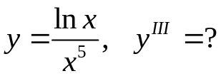
y'= x⁴-5x⁴lnx = 1-5lnx
x⁵ x
y''= -5-1+5lnx = 5lnx-6
x² x²
y'''= 5x-2x(5lnx-6) = 17-10lnx
x⁴ x³
18.24. 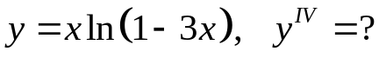
y'= ln(1-3x)-3x/(1-3x)
y''= 1/(1-3x) – 3(1-3x)+9x = -3x-2
(1-3x)² (1-3x)²
y'''= -3(1-3x)²+2(1-3x)(3x+2) = 15x+1
(1-3x)⁴ (1-3x)³
y''''= 15(1-3x)³-3(1-3x)²(15x+1) = 12-90x
(1-3x)⁶ (1-3x)⁴
18.25. 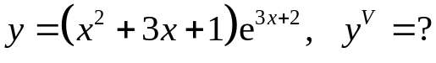
y'= 3e^{3x+2}(x²+3x+1)+e^{3x+2}(2x+3)= e^{3x+2}(3x²+11x+6)
y''= 3e^{3x+2}(3x²+11x+6)+e^{3x+2}(6x+11)= e^{3x+2}(9x²+39x+29)
y'''= 3e^{3x+2}(9x²+39x+29)+e^{3x+2}(18x+39)= e^{3x+2}(27x²+135x+126)
y''''= 3e^{3x+2}(27x²+135x+126)+e^{3x+2}(54x+135)= e^{3x+2}(81x²+459x+513)
y'''''= 3e^{3x+2}(81x²+459x+513)+e^{3x+2}(162x+459)= e^{3x+2}(243x²+1539x+1998)
18.26. 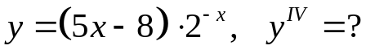
y'= -2^{-x}ln2(5x-8)+5*2^{-x}= 2^{-x}(5-5xln2+8ln2)
y''= -2^{-x}ln2(5-5xln2+8ln2)-5*2^{-x}ln2= 2^{-x}ln2(8ln2-10-5xln2)
y'''= -2^{-x}ln2(5-5xln2+8ln2)-5*2^{-x}ln²2= 2^{-x}ln2(-13ln2+10+5xln2)
y''''= -2^{-x}ln²2(-13ln2+10+5xln2)+5*2^{-x} ln²2= 2^{-x} ln²2(13ln2-5-5xln2)
18.27. 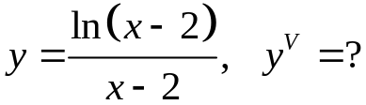
y'= 1-ln(x-2)
(x-2)²
y''= -(x-2)²-2(x-2)(1-ln(x-2)) = -x+2ln(x-2)
(x-2)⁴ (x-2)³
y'''= 2(x-2)²-(x-2)³-3(x-2)²(-x+2ln(x-2)) = 2x+4-6ln(x-2)
(x-2)⁶ (x-2)⁴
y''''= 2(x-2)⁴-6(x-2)³-4(x-2)³(2x+4-6ln(x-2)) = 24ln(x-2)-6x+14
(x-2)⁸ (x-2)⁵
y'''''= 24(x-2)⁴-6(x-2)⁵-5(x-2)⁴(24ln(x-2)-6x+14) = 24x-34-120ln(x-2)
(x-2)¹⁰ (x-2)⁶

18.28. 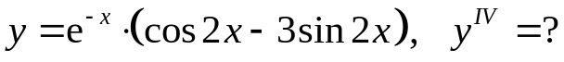
y'= -e^{-x}(cos2x-3sin2x)+e^{-x}(-2sin2x-6cos2x)= e^{-x}(sin2x-7cos2x)
y''= -e^{-x}(sin2x-7cos2x)+e^{-x}(14sin2x+2cos2x)= e^{-x}(13sin2x+9cos2x)
y'''= -e^{-x}(13sin2x+9cos2x)+e^{-x}(-18sin2x+26cos2x)= e^{-x}(-31sin2x+15cos2x)
y''''= -e^{-x}(-31sin2x+15cos2x)+e^{-x}(-30sin2x-62cos2x)= e^{-x}(sin2x-77cos2x)
18.29. 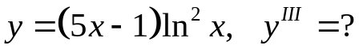
y'= 5ln²x+2lnx(5x-1)
x
y''= 10lnx/x+2(5x-1)+2xlnx(5x-1) = 10x²lnx+8xlnx+10x-2
x² x²
y'''= 20x³lnx+10x³+8x²lnx+8x²+10x² = 20xlnx+10x+8lnx+18
x⁴ x²
18.30. 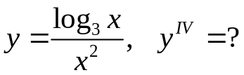
y'= 1-2ln3log₃x
x³ln3
y'' = -2x²-3x²(1-2ln3log₃x) = -5-6ln3log₃x
x⁶ln3 x⁴ln3
y''' = -6x³+4x³(5+6ln3log₃x) = 14+24ln3log₃x
x⁸ln3 x⁵ln3
y'''' = 24x⁴-5x⁴(14+24ln3log₃x) = -46-120ln3log₃x
x¹⁰ln3 x⁶ln3
18.31. 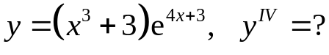
y'= 3x²e^{4x+3}+4e^{4x+3}(x³+3)= e^{4x+3}(4x³+3x²+12)
y''= 4e^{4x+3}(4x³+3x²+12)+e^{4x+3}(12x²+6x)= e^{4x+3}(16x³+24x²+6x+12)
y'''= 4e^{4x+3}(16x³+24x²+6x+12)+e^{4x+3}(48x²+48x+6)= e^{4x+3}(64x³+144x²+72x+54)
y''''= 4e^{4x+3}(64x³+144x²+72x+54)+e^{4x+3}(192x²+288x+72)= e^{4x+3}(256x³+768x²+576x+288)

